**Accounting Combination Integration**

Control M Job : FMSGB_P_NZL_OIC_01AD  
Run Control : OIC_ANZ_GEN_EXTR_CFCOMBO_D1

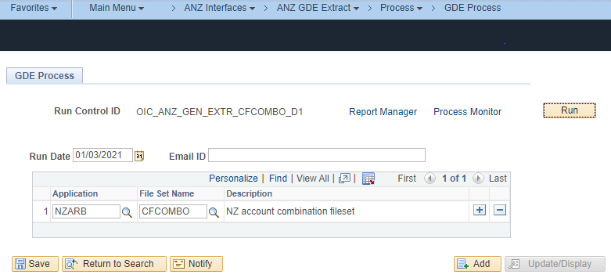

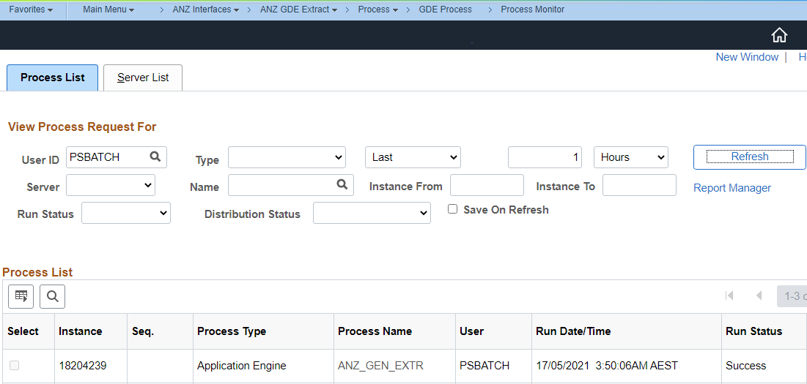

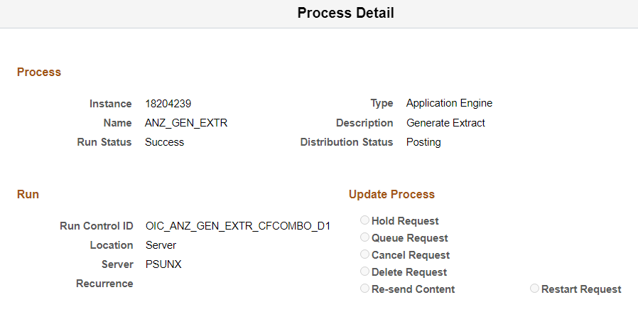

File generated in the specified NAS.

